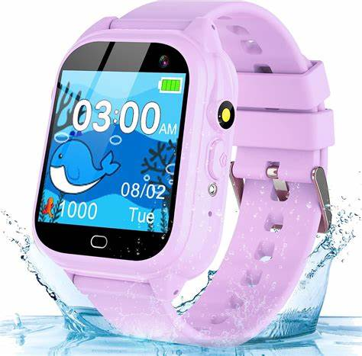**Description**: Fitbit is a popular brand of wearable fitness trackers and smartwatches designed to help users monitor their health and activity levels. The devices track various metrics such as steps taken, heart rate, sleep patterns, calories burned, and even stress levels, providing insights to improve overall well-being. Fitbit products sync with a mobile app, allowing users to set goals, analyze progress, and stay motivated through challenges and social features. Acquired by Google in 2021, Fitbit continues to evolve with new technology, offering features like built-in GPS, oxygen saturation tracking, and integration with Google services for a more connected health experience.